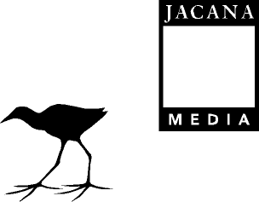



Press Release:
For immediate release

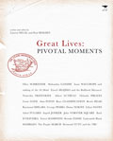

Great Lives: Pivotal Moments
Written and edited by Lauren Segal and Paul Holden

EAN/ISBN: 978-1-77009-592-2
Format: Trade paperback
Size: 235 x 155mm
Extent: 215pp.
Recommended Retail Price: R260
Published by Jacana Media in September 2008
Rights: World

South Africans are living in momentous times. As 2008 draws to a close we find ourselves standing at an important crossroads in our country’s history with change and flux all around us. This feels like a highly pertinent time to honour the people, the organisations and the moments that have brought South Africa and South Africans to where we find ourselves today.

As part of its centenary in 2006, the Sunday Times newspaper created a trail of street memorials across South Africa to celebrate newsmakers and important events of the last 100 years. Great Lives: Pivotal Moments tells the stories behind these memorials.

The book celebrates an exciting sweep of South African history, and honours ordinary and extraordinary people and moments in South Africa’s past – from Olive Schreiner’s fight for women’s rights to Archbishop Desmond Tutu’s leadership of the Truth and Reconciliation Commission. Great Lives honours anti-Apartheid stalwarts such as Lilian Ngoyi, Cissie Gool and Nobel Laureate Albert Luthuli. The book also includes not to be forgotten characters like Brenda Fassie, “The Madonna of Soweto”; Grammy-winning Ladysmith Black Mambazo; the troubled poet, Ingrid Jonker, and cricket’s Basil D’ Oliveira. Not forgetting the incredible stories of Cape Town’s Purple March on 2 September 1989, the Bulhoek Massacre on 24 May 1921 and the infamous history of John Vorster Square.

Each intimate portrait reveals the impact that segregation and apartheid had on people’s daily lives. The stories demonstrate the great hardships that were imposed. But most importantly, they also demonstrate the individual and collective spirit of courage and resistance that has characterised much of the struggle for democracy in this country. The narratives on these pages are enriched by the hitherto unseen archival treasures and images gathered by the team from the South African History Archive.

Great Lives: Pivotal Moments is a read-all-at-once, as well as a dip-into book for all South Africans wanting to remember, learn about and celebrate who we are.

The book is the product of an extensive collaborative project undertaken by the South African History Archive (SAHA) and the Sunday Times Heritage Project, funded by The Atlantic Philanthropies.

About the Authors
Lauren Segal holds postgraduate degrees in history, film and television studies. She has written several books and has produced award-winning educational television. She is currently director of an exhibition and design company and works as a curator, heritage consultant and project director for multi-media campaigns.

Paul Holden holds a postgraduate degree in South African history. He currently works as a freelance historian, researcher, writer and heritage practitioner. He has recently published a book on the arms deal in South Africa.
For all media enquiries, review copies, or interview requests please contact:
Oageng Tsatsi
011 628 3210
oageng@jacana.co.za
For sales enquiries contact:
Nteseng Thoane
011 628 3222
nteseng@jacana.co.za

